This letter is for you to adapt for your patient(s). Please ensure that you customise the text highlighted in yellow so that the information is appropriate. Please also ensure that once you have made your amendments, any important information isn’t split across two pages, or that an instruction to continue on to a second page is added.

Insert practice header, print to practice headed paper or type out the address below

[Practice name]
[Address]
[Tel]
[Fax]
[Email]
[Date]
[Title/Initial/Surname]
[Patient Address Block]
Dear [Title] [Surname],
Re: Antiepileptic drugs (AEDs) – Changing between different manufacturers’ products

We are currently reviewing the use of antiepileptic medicines in line with recent MHRA guidance (Appendix 1). These drugs are used to treat epilepsy and other conditions such as nerve pain. We have found that you have been prescribed a branded product called [insert name] to treat epilepsy.

Your doctor is considering changing your medicine to a generic (unbranded) version but this will only happen where it is appropriate for you, so please don’t worry that your medicine will be changed without you being involved.

Please make an appointment with your doctor/practice pharmacist to discuss this proposed switch from branded to generic medicine.
You will be able to talk to your doctor/practice pharmacist about whether it is right for you, based upon your condition and past treatment.

Yours sincerely
Dr [Name] and partners
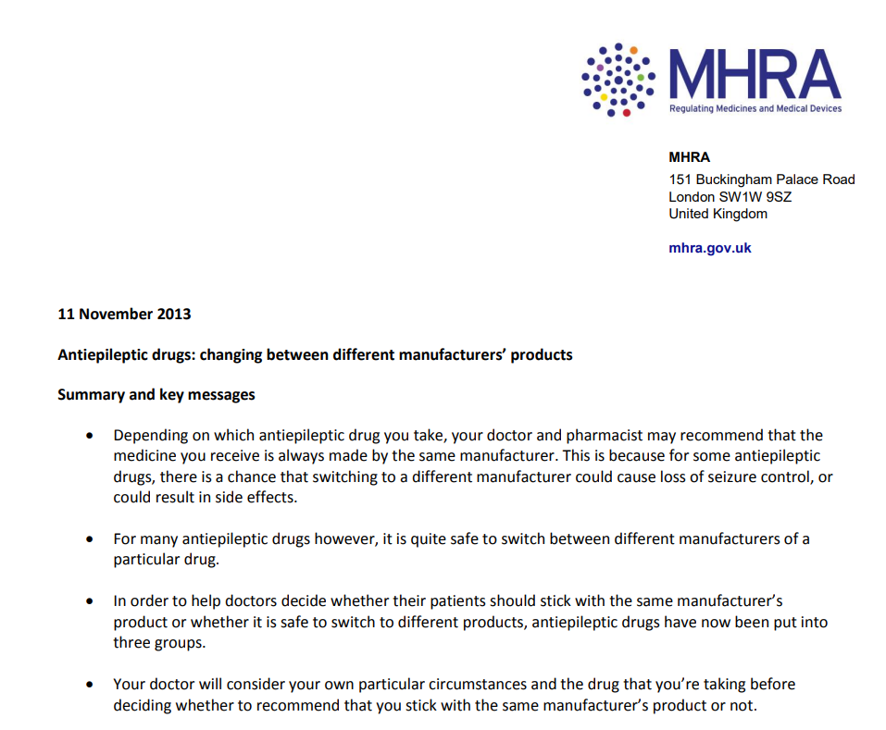
Appendix 1

