Direct Oral Anticoagulant (DOAC) Audit
Eloise Cruickshank, Trainee Pharmacist, University Hospital Dorset
Introduction
Direct Oral Anticoagulant (DOACs) are approved for a variety of uses related to anticoagulation. DOACs increase the risk of bleeding and can cause serious, potentially fatal bleeds.^{[1]} DOACs should be used with caution in patients with increased bleeding risk such as older people, patients with low body weight or renal impairment. The dosing of DOACs is dependent on indication and patient factors including weight, age, and renal function. Exposure to DOACs is increased in patients with renal impairment. Using estimated glomerular filtration rate (eGFR) to determine doses can overestimate renal function and increase the risk of bleeding.^{[1]} While DOAC therapy is beneficial in prophylaxis of stroke and systemic embolism as well as in the treatment, patients are at an increased risk of bleeding or clot formation with inaccurate dosing.
A small audit of DOAC dosing was conducted in two GP practices during 2017-2018; this audit identified a sample of patients who were on an incorrect dose, in reference to their renal function, age and weight. The remit of the audit was expanded in 2019 to cover 82 practices within Dorset which identified that dosing is often incorrect and that there is a lack of appropriate monitoring in patients taking DOAC’s.^{[2]}
The objective of this audit was to ensure that patients on DOAC’s in primary care are appropriately monitored and are on an appropriate dose for their indication, weight, renal function, and age. All practices within Dorset were asked to audit all patients taking DOAC’s (Apixaban, Dabigatran, Edoxaban, and Rivaroxaban) for Atrial Fibrillation, Deep Vein Thrombosis, Pulmonary Embolism, and any other indications, to ensure they were on the appropriate doses and all prescriptions had a documented indication.

Audit Standards
A – 100% of patients prescribed a DOAC should have had appropriate monitoring of their renal function.
B – 100% of patients prescribed a DOAC should have an appropriate dose given their indication, age, weight, and renal function.
C – 0% of patients prescribed a DOAC should have a dose which is too high for their indication, age, weight, and renal function
D – 0% of patients prescribed a DOAC should have a dose which is too low for their indication, age, weight, and renal function

Method
As part of the Medicine Optimisation Plan (MOP) in 2019, GP practices in Dorset were asked to identify and review patients taking DOACs for non-valvular AF. This audit was then replicated in 2021, to include DOACs for atrial fibrillation (AF), deep vein thrombosis (DVT), pulmonary embolism (PE) and any other indications.
Practices were provided with a template in which to submit the results (Appendix 1), the form included the following factors for each of the four DOACs (Apixaban, Dabigatran, Edoxaban and Rivaroxaban):
- Number of patients prescribed the DOAC
- Number of patients prescribed the DOAC for each indication
- Number of patients prescribed DOACs with creatinine clearance checked within the appropriate timeframe.
- Number of patients prescribed the DOAC at an appropriate dose
  - Number of patients prescribed the DOAC at a dose which was too high
  - Number of patients prescribed the DOAC at a dose which was too low
The clinical commissioning group (CCG) provided guidance to the practices to support them in the completing the audit, including data collection templates (Appendix 1), instructions on calculating creatine clearance (CrCl), a table indicating the renal function monitoring requirements of each DOAC and search codes to identify patient numbers.
Sample
Data was collected from 77 surgeries across Dorset, these surgeries were then split into their primary care networks (PCNs). 2 practices did not complete the audit (Stour Surgery and Sandford Surgery).
Results
22,606 people in Dorset are currently being prescribed a DOAC, where continued treatment is required. Of which 12,124 are prescribed apixaban, 1002 prescribed Dabigatran, 2610 prescribed Edoxaban, 6870 prescribed Rivaroxaban.
Overall Dosing Accuracy
DOAC | % Dosed Correctly
Edoxaban | 83%
Rivaroxaban | 80%
Apixaban | 80%
Dabigatran | 76%
Total | 80%

For the purpose of this audit, the compliance with the above standards was assessed per DOAC to ascertain whether there were any differences between the DOAC in terms of monitoring and appropriate dosing.

Sherborne PCN demonstrated the highest number of patients (94%) who had appropriate monitoring of their renal function whilst on Apixaban. This was closely followed by Crane Valley PCN where 92% of patients had their creatinine clearance assessed within an appropriate time frame. Poole North PCN had the lowest percentage of patients (28%) who had creatine clearance monitored within an appropriate time frame, this was closely followed by Jurassic Coast (31%). Blandford PCN had the highest percentage of patients on an appropriate dose (97%), followed by Bournemouth East PCN, Sherborne PCN and Shore Medical PCN (95%). All the PCN had at least 1% of patients on a dose considered to be too high bar Central Bournemouth (0%), and all bar 1 PCN (Vale, 0%) had patients prescribed a dose of Apixaban considered to low for their indication, age, weight, and renal function.

Crane Valley PCN demonstrated the highest number of patients (90%) who had appropriate monitoring of their renal function whilst on Dabigatran. This was closely followed by Purbeck PCN where 89% of patients had their creatinine clearance assessed within an appropriate time frame. Jurassic Coast PCN had the lowest percentage of patients (22%) who had creatine clearance monitored within an appropriate time frame, this was closely followed by Poole North (27%). Shore Medical PCN had the highest percentage of patients on an appropriate dose (96%), followed by Blandford PCN (95%). All the PCN had at least 1% of patients on a dose considered to be too high bar; Blandford (0%), Central Bournemouth (0%), Poole Bay (0%) and Shore Medical (0%). Only Central Bournemouth PCN, Christchurch PCN, Jurassic Coast PCN, North Bournemouth PCN, Poole Bay PCN, Poole North PCN and Vale PCN had 0% of patients prescribed a dose of Dabigatran considered too low for their indication, age, weight, and renal function.

Blandford PCN demonstrated the highest number of patients (94%) who had appropriate monitoring of their renal function whilst on Edoxaban. This was closely followed by Crane Valley PCN where 93% of patients had their creatinine clearance assessed within an appropriate time frame. Central Bournemouth PCN had the lowest percentage of patients (32%) who had creatine clearance monitored within an appropriate time frame, this was closely followed by South Coast Medical (34%). Wimborne PCN had the highest percentage of patients on an appropriate dose (99%), followed by South Coast Medical PCN and Blandford PCN (94%). All the PCN had at least 1% of patients on a dose considered to be too high bar Wimborne (0%). Only Blandford PCN, Poole Bay PCN and Vale PCN had 0% of patients prescribed a dose of Edoxaban considered too low for their indication, age, weight, and renal function.

Crane Valley PCN demonstrated the highest number of patients (91%) who had appropriate monitoring of their renal function whilst on Rivaroxaban. This was closely followed by Poole Bay PCN where 88% of patients had their creatinine clearance assessed within an appropriate time frame. Poole North PCN had the lowest percentage of patients (25%) who had creatine clearance monitored within an appropriate time frame, this was closely followed by South Coast Medical (26%). Bournemouth East PCN had the highest percentage of patients on an appropriate dose (97%), followed by South Coast Medical PCN and Blandford PCN (96%). All the PCN had at least 1% of patients on a dose considered to be too high bar Vale PCN and Central Bournemouth PCN (0%). Blandford PCN, Bournemouth East PCN, Central Bournemouth PCN, Crane Valley PCN, North Bournemouth PCN, Poole Bay PCN, Vale PCN had 0% of patients prescribed a dose of Edoxaban considered to low for their indication, age, weight, and renal function.

Discussion
The National average for incorrect dosing of DOACs is 16% and has identified as a priority for medicines safety improvement by the Chief Pharmaceutical Officer and Regional Medicines optimisation Committees in 2022. Dorset therefore is performing significantly worse than the national average as a system and increasing risk of harm to patients^{[3]}.
A lack of familiarity with DOACs including their different and individually complex dosing regimens is thought to contribute to patients being initiated and/or maintained on the incorrect dose. From the results we can see there is vast room for improvement in the monitoring of DOACs within PCN, many GP surgeries reported that poor monitoring was due to limited recording of patient’s weight/outdated weight reports. Weight is an essential part of calculating CrCl. Other GP surgeries reported that CrCl was not regularly recorded compared to eGFR, this may lead to surgeries attempting to use eGFR to calculate doses and monitor renal function, however it is essential that PCNs are educated on the importance of using CrCl to calculate doses of DOAC rather than using eGFR as eGFR can overestimate renal function and increase the risk of bleeding events.
No PCNs met all 4 standards set out within the audit. On comparison of standard A and standard B, we can see that patients were more likely to be on the correct dose but less likely to have appropriate monitoring of renal function completed within the required timeframe. DOACs are still relatively new agents, and their usage is continuing to expand, although they do not require routine INR monitoring like warfarin they do present their own issues including dose adjustment in renal impairment. The consequences of either therapy being poorly managed may be severe for the patient.
It should be noted that this audit was undertaken during the COVID-19 pandemic, where extreme pressures and uncertainty were present. During the time of the audit, GP practices had to adapt to unforeseen issues and priorities and adapt their practice methods. Consequently, routine monitoring and patient recall/reviews may have been less prioritised, and practices may still be catching up on these aspects of practice. Furthermore during 2021, there was a national shortage of blood bottles within primary and secondary care which resulted in only clinically urgent testing being completed, therefore patients undergoing routine monitoring may have had blood tests delayed.

Limitations
Some practices completed the data collection so late in the audit period that it is possible they may not have addressed the patients identified as being on the incorrect dose. The audit was originally meant to be undertaken in 2021 but was extended to 2022, in light of the pandemic. | Limitation of the study was that the percentages did not add up to 100%; for example, it was noted a practice recorded 131 patients on Apixaban of which 77 had an appropriate dose, and 1 on a dose to low. This means 53 patients were unaccounted for in terms of dosing. This was a repetitive theme within the audit.
The audit did not identify where the DOAC was initiated e.g., primary care or secondary care. | Many practices had up to date records of eGFR for patients, but CrCl was not recorded within SystmOne hence low results were seen for appropriate monitoring, education around the using CrCl for DOACs is essential.
Incorrect coding within clinical records may have resulted in people being coded for multiple indications and therefore there may have been some replication of patients within the results. | One surgery reported that a limitation was the identification of patients and reported that those on Electronic Reporting Dispensing (eRD) were not as easily identified in the search process.
The audit highlighted parameters such as weight (required to calculate CrCl) and U&Es were not recorded on the patient’s record and so there was additional information required before the practices could properly assess if patients were on the correct dose. Many practices surgeries reported robust new systems in place to ensure weight was recorded and was relatively recent and that bloods were taken to ensure creatine checks could be performed. | The audit gave advice on calculating CrCl; however, no advice was given around the use of Ideal Body weight to calculate CrCl in patients with a BMI >30, as adipose has limited influence on drug handling ^{[4]}. Similarly, some GP practices also highlighted the need to review patients with body weight >120kg due to insufficient evidence of DOACs in these groups.

Conclusions
Dorset is an outlier in DOAC prescribing accuracy nationally. The audit standards were not met of 100% accuracy of monitoring and dosing.
Dosing inaccuracy rates are at 20% and there is a lack of appropriate renal function monitoring for patients. There are pockets of good practice where dosing accuracy is higher. Anecdotally those PCNs have implemented safety management systems in collaboration with practice management and PCN pharmacy teams. It is vital that shared learning is developed between practices and networks to disseminate what is working well in those areas.

Recommendations
The clinical commissioning group has provisionally reviewed the audit report and recognise the drawbacks of the study and audit design. Consequently, the following recommendations were made:
- Best Practice Medicines Quality Procedures need to be shared within PCNs and in the system to automate patient recall and assessment in place to safety net patients in the future.

- Simplification of DOAC prescribing in AF may reduce inaccuracy in dosing accuracy due to differing dosing adjustment criteria.

- Explore development of an automated calculation/function that translates creatinine to CrCl for patients who have had their weight calculated in the last 12 months to support accurate assessment.

- ERD prescriptions should be aligned with their blood tests requirements (e.g., in those with 6 monthly blood tests, there ERD should be set up for 6 monthly scripts to be signed of after there blood tests are reviewed) this will help to reduce patients being missed from SystmOne searches.

- Revise audit criteria and collection tools to clarify interpretation of time frame within the data set for correct dosing based on creatinine clearances retrospectively calculated based on creatinine results within the last 12 months. There should also be a note about reviewing patients with a body weight >120kg as in this cohort of patients DOACs are not recommended.

- Re-audit compliance in 2023 to assess improvement.

References
[1] GOV.UK. Direct-acting oral anticoagulants (DOACs): reminder of bleeding risk, including availability of reversal agents [Internet]. MHRA;2020. Avaliable from: Direct-acting oral anticoagulants (DOACs): reminder of bleeding risk, including availability of reversal agents - GOV.UK (www.gov.uk)
[2] Ingram, S. Primary Care Medicines Optimisation Audits Dorset CCG 2018-9. Dorset CCG: 2019.
[3] Chief Pharmaceutical Officer Webinar Feb 2022.
[4] Safer DOAC Prescribing Education Session MORAG [PowerPoint].

Appendix 1
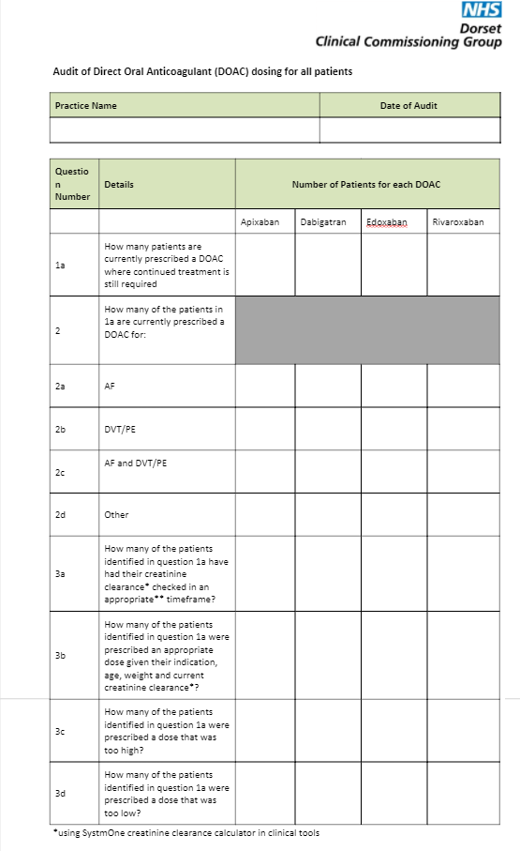
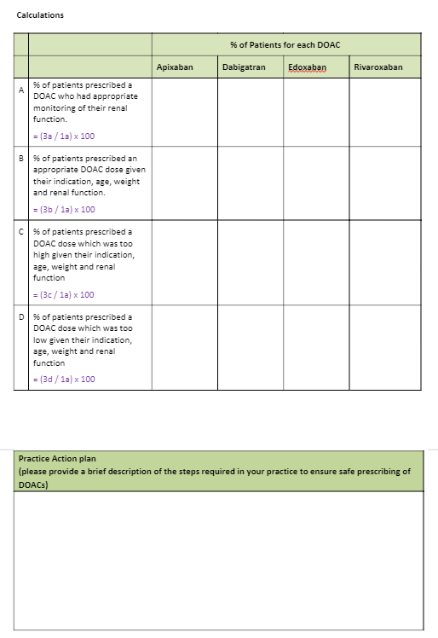

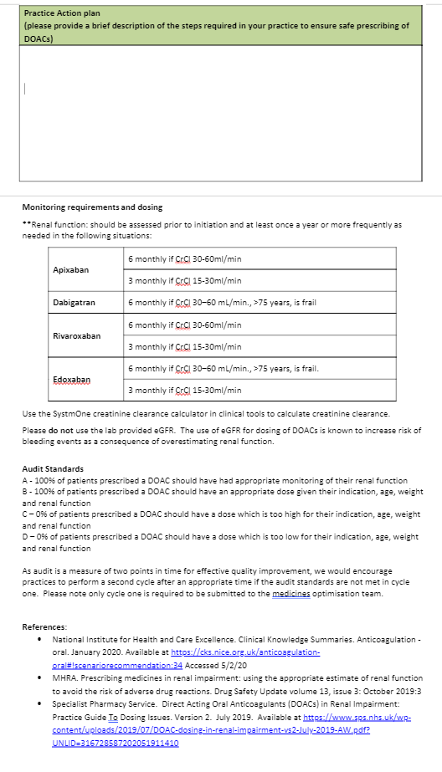

Appendix 2
