DOAC Safety

Technical support information

Blood test management

These are the searches that can be used to systematically manage your DOAC patients and ensure they are recalled for blood tests after the appropriate time interval.
The first search should be run as a batch report every fortnight and sent to the pharmacy team. This looks for all patients on a DOAC, who have had renal function monitoring but no creatinine clearance (CrCl) calculated. The pharmacy team can then calculate and record the patients CrCl and check their dose is correct.
The second set of 3 searches relies on the pharmacy team regularly completing CrCl from the first search. These searches can then be set up as a batch report for the blood recall team and run monthly. They will pick up patients who have not had renal function monitoring and CrCl in the last 13, 6 or 3 months depending on their previous results and DOAC dose*.

SystmOne view of patients with serum creatinine but CrCl not updated
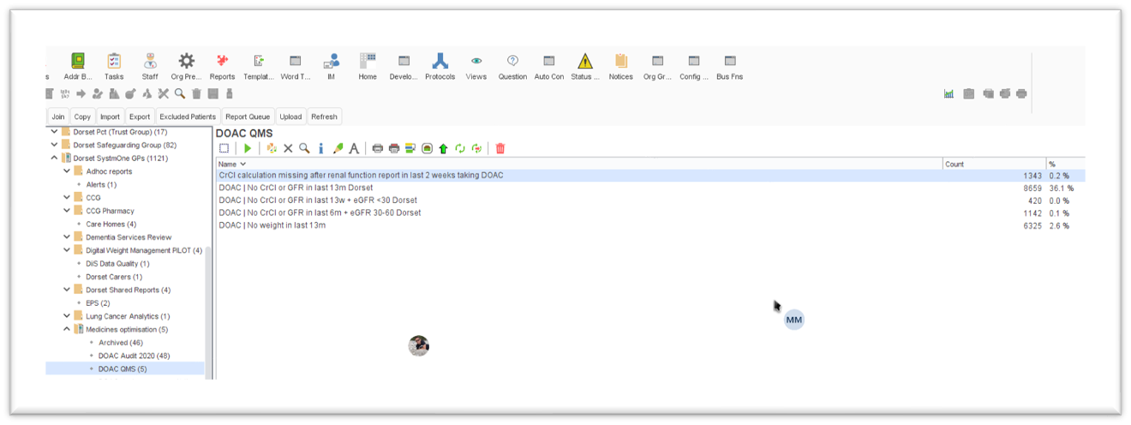

If you are a practice where renal monitoring has not been done systematically in the past you might want to focus initially on any patient who has not had a renal function test within the last 13 months.

Dosing Accuracy

The following searches should be done at time intervals appropriate to your practice and may not need to be run as frequently once blood test management has been established as described above.
The searches allow you to identify patients who may be either under or over dosed, as indicated by dose dictating parameters, on any particular DOAC.
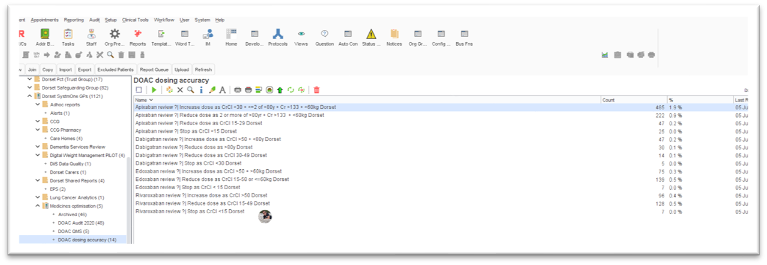
SystmOne view of DOAC dosing accuracy searches

*Renal function should be assessed prior to initiation and at least once a year or more frequently as needed in the following situations:

Apixaban | 6 monthly if CrCl 30-60ml/min
 | 3 monthly if CrCl 15-30ml/min
Dabigatran | 6 monthly if CrCl 30–60 mL/min., >75 years, is frail
Rivaroxaban | 6 monthly if CrCl 30-60ml/min
 | 3 monthly if CrCl 15-30ml/min
Edoxaban | 6 monthly if CrCl 30–60 mL/min., >75 years, is frail.
 | 3 monthly if CrCl 15-30ml/min

