Standard Operating 3. Procedure for Medication Review by Independent Prescribing Nurses
Objectives
To describe the procedure for Medication Review at insert name by IP nurses

Scope
- Medication Reviews undertaken by IP nurses
- Structured Medication Reviews and Medication Reviews undertaken by GPs/ Pharmacists/ pharmacy technicians are NOT covered
- If the nurse IP’s scope of practice doesn’t cover all the medications that a patient is prescribed, then the repeat authorisation needs to be undertaken by a GP.
- These reviews are undertaken as part of a long-term condition review

The Stages of the process

- Patient is highlighted as needing a medication review. This may be an annual medication review as part of annual recall process or at a specific point in time as decided by the prescriber, based on national clinical recommendations. See Appendix 1 for who can do which medication reviews.
- The patient is booked in for a long-term condition review either face to face, telephone or a paper-based review.
- Attempt to contact is made on three occasions, these invites should be coded

- Telephone call (not coded)
- SMS/ email/ letter (sent on same occasion as i)
- Letter or email (sent 2-4 weeks later)
- If the patient declines/ does not respond, then code as such and then a task sent to GP
- If the patient is booked in for an appointment with a non- IP LTC nurse OR the patient has medication not covered by the LTC then the pharmacy team MUST send a task to the GP to complete a medication review
- The nurse ensures that:
  - All relevant clinical tests have been performed (for example bloods, peak flows)
  - The patient is ordering all medication regularly and that they are not experiencing any problems with their medication.
- The medication review is recorded as below
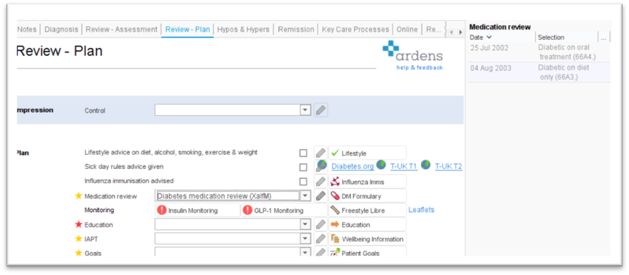

- The review & reauthorisation should take place concurrently.
- It is advised that when undertaking a medication review that a systematic approach is undertaken, suggestions for these are in appendix 3.
- All medications must be reauthorised (using the green triangle and selecting all medication) for another set period of time depending on the patient’s needs, although usually 1 year
Responsibility and accountability

- Responsibility for medication review lies with the nurse.
- It is the responsibility of the pharmacy team to highlight those patients that require medication review.
- Overall responsibility lies with the Partner in charge of Medicines Optimisation/ Prescribing.

Training and competencies

- Staff should have training on medication review process at insert name as part of the induction process.
- Training should be provided to all those involved in the process, this includes GPs, pharmacists, pharmacy technicians, patient services, dispensary staff.
- Training to be repeated on an as required basis and if the process changes.

Record keeping

Records of medication review should be added to the patient notes.

Other information

GMC. Good Practice in prescribing and managing medicines and devices. April 2021
RPS. Medication Review. Quick Reference Guide.
NICE. Quality Standard (QS 85). Medicines Management in Care Homes. March 2015
NICE. Medicines Optimisation: the safe and effective use of medicines to enable the best possible outcomes. March 2015
NICE. Quality Standard. Medicines Optimisation. March 2016
QoF. S4. How does the provider ensure the proper and safe use of medicines, where the service is responsible? May 2022
Medicines Standard 2. Medication Review

If the SOP is not being followed this should be discussed with the partner responsible for medicines optimisation/ pharmacist/ practice manager.

Breaches should be reported via internal error reporting system.

Review

This SOP will be subject to review on a yearly basis or sooner in the light of new local or national guidance.

Date of preparation
Review date

Author name
Author signature
Authorising manager
Name (PRINT)
Authorising manager signature

I have read and understood the SOP for [insert subject]

Name (PRINT) | Sign | Date

Appendix 1. Delegation of medication reviews

GP | Pharmacist | Pharmacy Technician | Nurse independent prescribers
All reviews that cannot be undertaken by another group | Those that meet the criterion as set out in the impact and investment fund for a structured medication review | Patients with hypertension where blood tests are satisfactory and blood pressure well controlled | Medication reviews where all the patient’s medication fall within their field of competency. For example:  *Diabetic medication  *Medicines for hypertension  *Asthma/ COPD medication  *Medicines for depression  *Contraceptives  *HRT
 | Those requested by GP or Frailty team due to concerns about medicines- for example compliance/ appropriateness | Patients with hypothyroidism where blood tests and satisfactory
 |  | Patients with only P/ GSL medicines on repeat
 |  | Patients on statins for primary prevention

Appendix 2. Template letter medication review

Dear [Title & Surname]
RE: Invitation for a medication review

We wish to invite you [to the practice] or [for a telephone / video call/ face to face] for a routine review of your current medication. The purpose of the medication review is to help you get the best from your medication and to make sure that the medications that you are taking continue to be safe and effective for you.

At the review, a GP, Pharmacist or Nurse will check that your medicines are working for you and that you are not having any problems with them. You will have the opportunity to ask any questions you may have about your medicines. If any changes need to be made to your medication, your agreement will be sought before changes are made and we can discuss why we feel a change would be beneficial for you.

Please make an appointment to have a medication review within the next 1 month by calling the surgery or booking on line. For a face to face review please bring all your medicines (which may include tablets, capsules, liquids, creams, ointments and inhalers to the review or if a telephone review please make sure you have a list of all your current medicines. This includes prescribed medication as well as any herbal medicines or any medicines that you buy over the counter from the chemist or supermarket and also medication you no longer take.

If you have any queries, please do not hesitate to speak to your community or practice pharmacist, nurse or GP.

Yours sincerely,
[GP practice signature]
Appendix 3. Examples of aids when undertaking a medication review

Recommended general process:
- Does patient have capacity to be involved? What adaptations do I need to make? (interpreter, pictorial support)
- Is the technology in place on both sides to enable a consultation
- Can the patient verbalise needs or communicate in another way
- Check allergies
- OTC/ CAM/ illicit drug use
- Think about medicines on acute that should go on repeat/ repeat medicines that ae not appropriate
- Remove any medications that have not been issued in a year, except possibly seasonal medication like antihistamines
- Think about falls, continence, sleep, fluid and dietary intake, mobility, pain
- Use a tool such as 7 steps
- Complete any outstanding QOF if possible
Medication review tools
NO TEARS
STOP/ START toolkit
7- steps medication review
Anticholinergic burden
BRAN
STOMP

